**Bash Script Tasks**

1. Create a bash script to **check if a directory is available or not**.

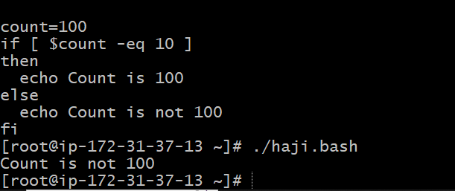

1. Create a bash script to **create multiple files**.

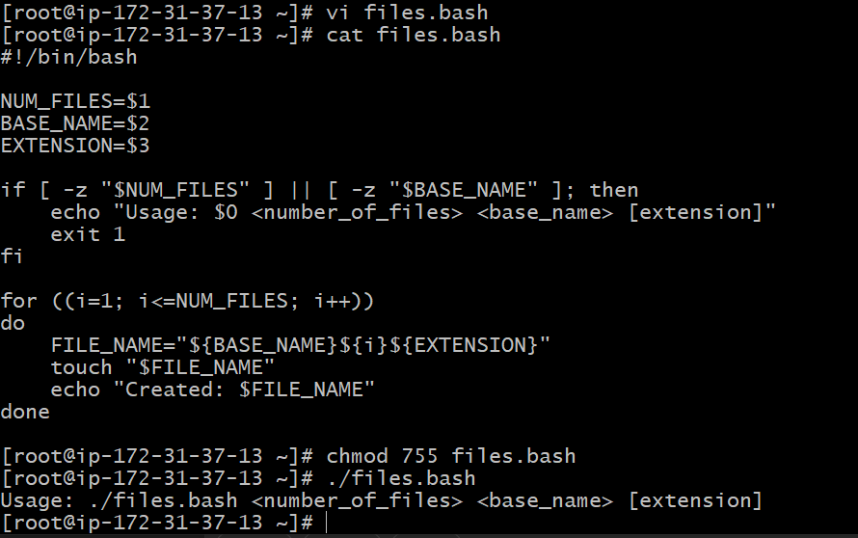

1. Create a bash script to **take a backup of a directory**.

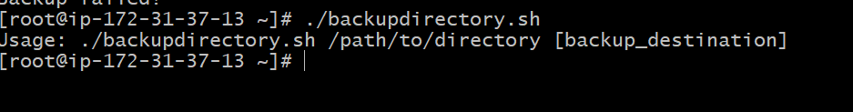

1. Create a bash script to **install Nginx on an EC2 server**.

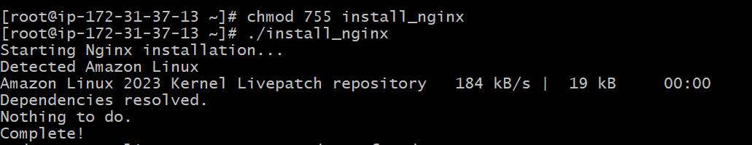

1. Create a bash script to **install Apache Tomcat on an EC2 server**.

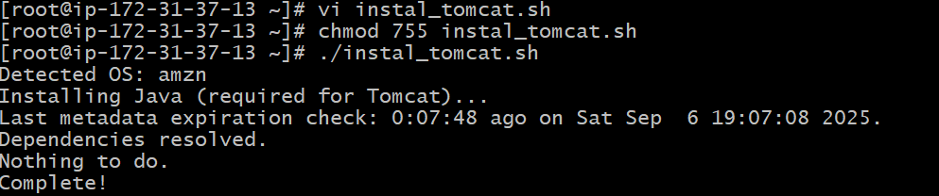

1. Create a bash script to **check if the Nginx service is running**, if not running then script should start the service.

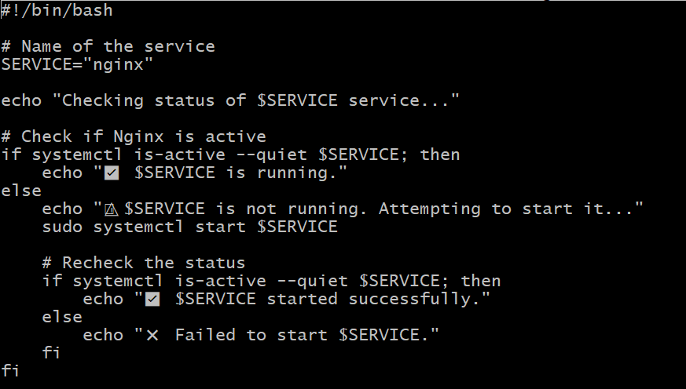

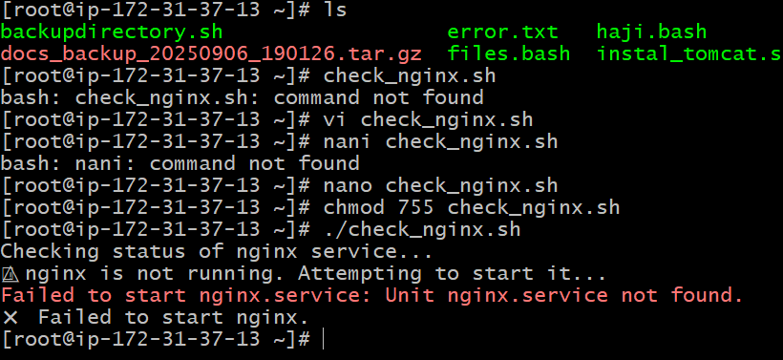

1. Create a bash script for a **calculator**.

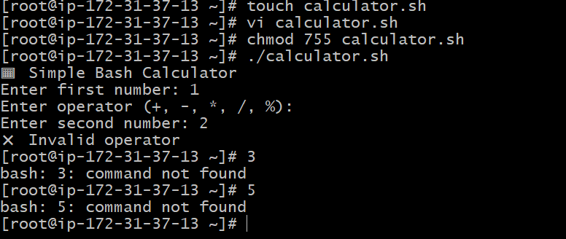

1. Create a bash script to **check if a directory exists**, if not then create a directory.

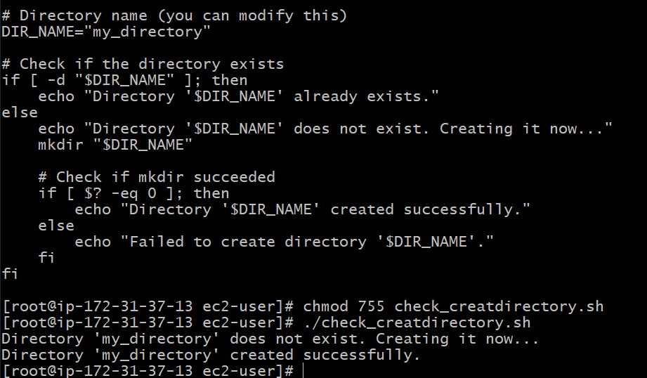

1. Create a bash script to **delete the last 3 lines of a file**.

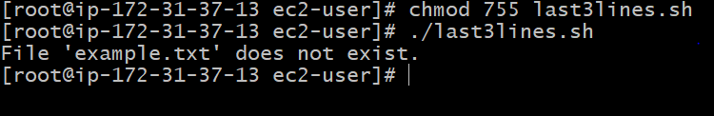

1. Bash script to monitor cpu and if it is more than 80% then send email notification.

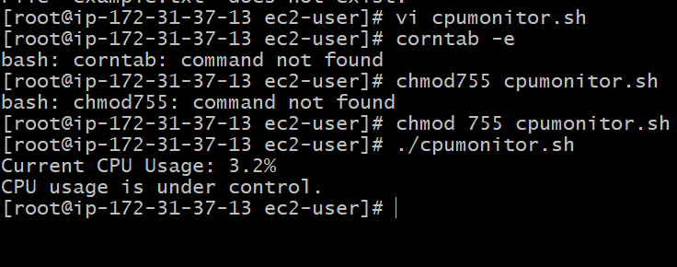

1. Bash script to monitor disk space and if it is more than 80% then send email notification.

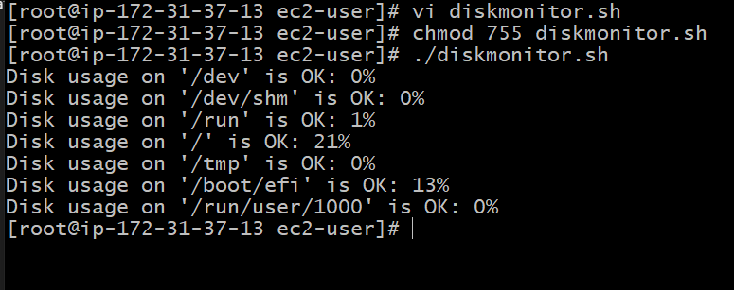

1. Bash script to monitor memory and if it is more than 80% then send email notification.

